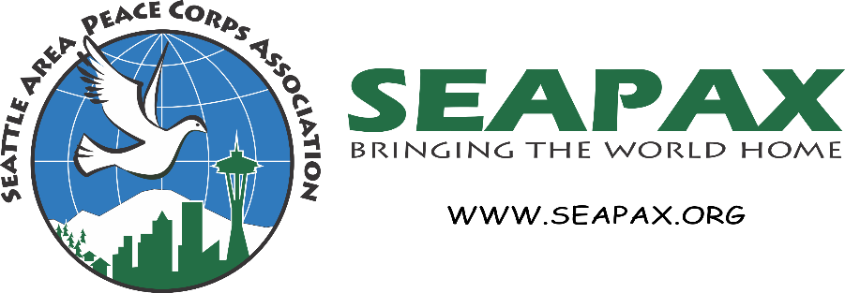

Checklist for Posting to SEAPAX Newsletter and Social Media Platforms
The purpose of this form is to help you gather the details SEAPAX needs to promote your event, webinar, activity or other announcement on its social media platforms.
RPCVs/PCVs are encouraged to join and post directly to the SEAPAX Facebook RPCV/PCV Community Group. Other friends of SEAPAX, please forward your completed form to info@seapax.org, and we will take it from there.

- Your Names
- Email
- Title of Announcement
- Description
- Is this an Event?
- YES [Complete numbers 6-8]
- NO [Skip to number 12]

- Date
- Start Time
- End Time
- Will the Event take place in person?
- YES [Complete number 10]
- NO [Skip to number 11]

- Address

- Link for virtual meeting
- Link to register or obtain additional details
- Website of sponsoring organization
- Email of contact for additional questions if different than submitter

